Modern Education Society’s
Nowrosjee Wadia College, Pune(Autonomous)

Department of Computer Science
T.Y.B.Sc(Information Technology)

Mini Project Report
“Student Pass/Fail Prediction Using Machine Learning”
A Supervised Learning Project Using Statistical Analysis and Linear Regression
Submitted By :
Name : Deepkanya Baliram Rokade
Class : T.Y.B.Sc ( IT )
Roll No : 59
Instructor (Mentor): Pfrof.Shraddha Khandre

Academic Year : 2026-2027

1. Introduction
Machine learning is increasingly being used in the education sector to analyze student-related data and support academic decision-making. Student performance can be influenced by several factors, including attendance, study habits, demographic information, and other personal and educational characteristics.
Predicting student outcomes can help identify students who may require additional academic guidance and support. In this project, machine learning techniques are used to predict whether a student will pass or fail.
The project uses Logistic Regression models to analyze student-related features and compare their performance. Special attention is given to class imbalance because the number of passing students is significantly higher than the number of failing students. The project also evaluates the models using accuracy, precision, recall, F1-score, and a confusion matrix to understand their performance.

2. Problem Statement

Student Performance Prediction
Educational institutions need to identify students who may be at risk of failing so that they can provide academic support at an early stage.
The objective of this project is to develop a machine learning model that predicts whether a student will pass or fail using information such as attendance, study habits, demographic details, and other student-related factors.

The project also compares two Logistic Regression configurations to understand how class imbalance affects model performance.
3. Objectives
The main objectives of this project are:
- To analyze student-related data and identify factors associated with student outcomes.
- To perform data preprocessing, including checking missing values, duplicates, and selecting relevant features.
- To conduct Exploratory Data Analysis (EDA) using graphs and statistical observations.
- To develop Logistic Regression models for predicting whether a student will pass or fail.
- To compare balanced and unweighted Logistic Regression models using evaluation metrics.
- To evaluate model performance using accuracy, precision, recall, F1-score, and a confusion matrix.
- To identify a suitable model for detecting students who may be at risk of failing and require academic support.

4. Dataset Description
- Dataset: Student Performance Dataset
- Number of observations: 10,000
- Original number of variables: 25
- Target variable: passed
- Target values:
  - 0 → Fail
  - 1 → Pass

Target Distribution
Outcome | Number of Students | Percentage
Pass | 9,610 | 96.1%
Fail | 390 | 3.9%
Total | 10,000 | 100%
The dataset is imbalanced because the number of passing students is much higher than the number of failing students.
Interpretation: Since failing students represent a smaller group, accuracy alone may not be sufficient to evaluate the model. Fail recall is also important because it measures how many actual failing students are correctly identified.

5. Project Workflow
The following steps were performed in this project:
- Data Preprocessing: Checked for missing values and duplicates, and removed the unnecessary student_id column.
- Exploratory Data Analysis (EDA): Analyzed student performance using graphs, distributions, and correlation analysis.
- Feature Selection: Selected relevant features and excluded subject scores and overall GPA to reduce potential target leakage.
- Model Building: Developed two Logistic Regression models—one balanced and one unweighted.
- Model Evaluation: Compared the models using accuracy, precision, recall, F1-score, and a confusion matrix.
- Model Selection: Selected the balanced Logistic Regression model because it identified a higher proportion of students who failed.

6. EDA and Visualizations
Exploratory Data Analysis (EDA) was performed to understand the dataset and identify patterns related to student performance. Various visualizations were used to analyze the distribution of student outcomes, attendance, study hours, academic factors, and relationships between different variables.
The following visualizations were created:
- Distribution of Pass and Fail outcomes
- Attendance distribution
- Study hours distribution
- Average attendance by student outcome
- Average academic scores by outcome
- Study hours versus attendance scatter plot
- Correlation heatmap
These visualizations helped in understanding the dataset and identifying relationships between student-related factors and the target variable.
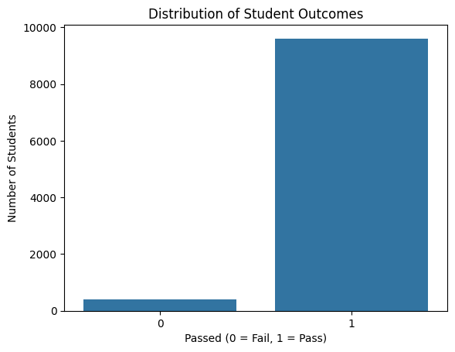
Interpretation:

The bar chart shows the distribution of student outcomes. The number of students who passed (1) is considerably higher than the number of students who failed (0). This indicates that the target variable is imbalanced, which we will should be considering while evaluating the machine learning model.

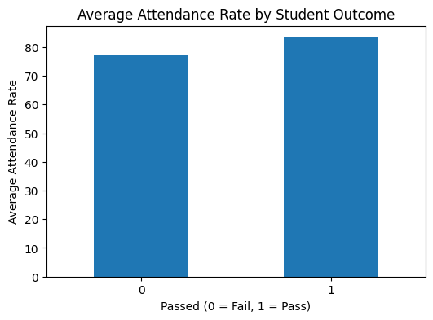
Interpretation:

The bar chart compares the average attendance rates of students based on their outcomes. Students who passed had a higher average attendance rate than students who failed. This suggests that attendance may be associated with student outcomes in this dataset.

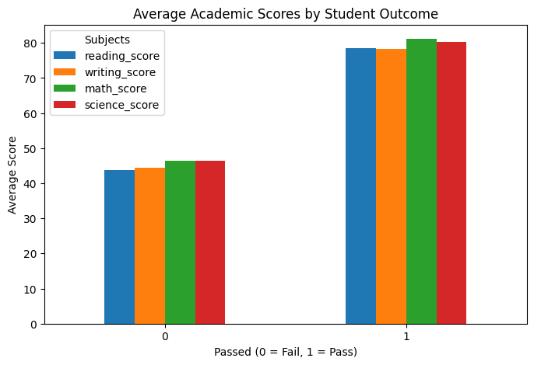
Interpretation:

The bar chart compares the average reading, writing, mathematics, and science scores of students based on their final outcome. Students who passed have higher average scores in all four subjects than students who failed. The passing group has an average mathematics score of approximately 81, while the failing group has an average mathematics score of approximately 46. Similar differences can be observed in reading, writing, and science scores. This indicates that academic performance is associated with the student outcome in this dataset. However, these results describe relationships in the dataset and do not independently prove that higher scores cause students to pass.

7. Model Building

7.1 Data Preprocessing
Before building the models, the dataset was prepared for machine learning. The unnecessary student_id column was removed because it does not contribute to predicting student outcomes.
The passed column was selected as the target variable. The overall_gpa and subject score columns were excluded from the input features to reduce the possibility of target leakage.
Numerical features were standardized using StandardScaler, while categorical features were converted into numerical form using OneHotEncoder. A preprocessing pipeline was used to apply these transformations.

7.2 Train-Test Split
The dataset was divided into training and testing sets using an 80:20 split. Stratified splitting was used to maintain a similar distribution of pass and fail outcomes in both sets.
The training data was used to train the models, while the testing data was used to evaluate their performance on unseen data.

7.3 Models Developed
Two Logistic Regression models were developed:
- Balanced Logistic Regression: This model used balanced class weights to give additional importance to the minority fail class.
- Unweighted Logistic Regression: This model used the default class weights without additional balancing.
Both models were trained using the same preprocessing pipeline and were evaluated using multiple performance metrics.
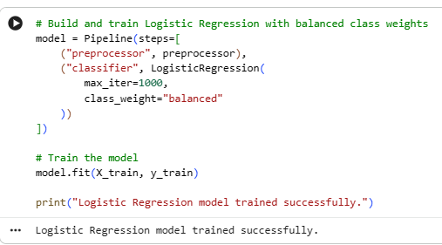
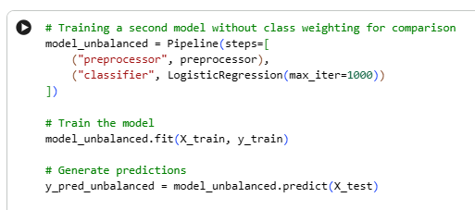

8. Model Evaluation
The developed models were evaluated using accuracy, precision, recall, F1-score, and a confusion matrix.
Because the dataset contained significantly more passing students than failing students, special attention was given to the performance of the fail class, particularly its recall.

8.1 Performance Comparison
Evaluation Metric | Balanced Logistic Regression | Unweighted Logistic Regression
Accuracy | 86% | 96.5%
Fail Precision | 20% | 70%
Fail Recall | 88.46% | 17.95%
Fail F1-Score | 33% | 29%
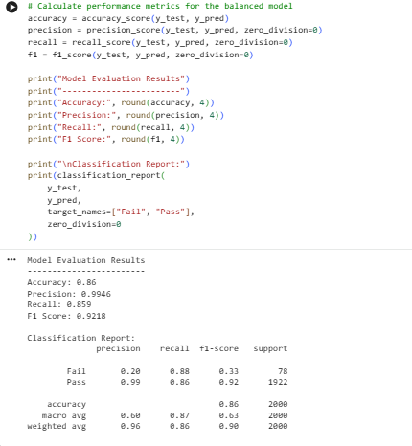
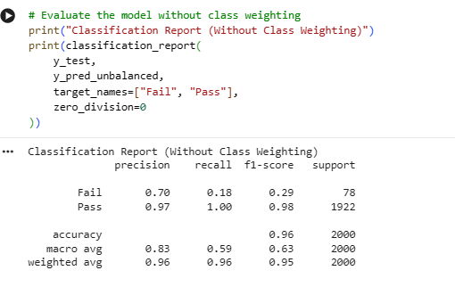
The unweighted Logistic Regression model achieved higher overall accuracy. However, the balanced Logistic Regression model achieved considerably higher recall for the fail class, meaning it identified a larger proportion of students who actually failed.

8.2 Model Selection
The balanced Logistic Regression model was selected as the primary model because the project focuses on identifying students who may be at risk of failing.
Although its overall accuracy was lower, it detected more actual failing students. Its predictions should be considered early warnings for providing academic support rather than final judgments about student performance.

9. Findings and Conclusion

9.1 Findings
The following findings were obtained from the project:
- The dataset contained a significantly higher number of passing students than failing students.
- The data was analyzed using different visualizations to understand student-related patterns.
- Two Logistic Regression models were developed and compared.
- The unweighted model achieved higher overall accuracy.
- The balanced model achieved higher recall for the fail class.
- Accuracy alone was not sufficient for evaluating the models because the dataset was highly imbalanced.
- The balanced model was selected as the primary model for identifying students who may require academic support.

9.2 Conclusion
In this project, Logistic Regression models were used to predict whether students would pass or fail based on student-related features. Data preprocessing, Exploratory Data Analysis, model development, and performance evaluation were performed using Python.
Two Logistic Regression configurations were compared: balanced and unweighted. Although the unweighted model achieved higher accuracy, the balanced model performed better in identifying students belonging to the fail class.
Therefore, the balanced Logistic Regression model was selected as the primary model for this project. The model can be used as an early-warning tool to help identify students who may need additional academic guidance. However, the predictions should not be considered final decisions about a student's performance.

